**Session report 25/04/2023:**

*LABAUVIE – RAFFAELLI EVA*

*ROB3*

This session’s goal is to model on Fusion 360 the box that will be around the wheel. I’m doing it in order to understand better what I’m doing, and be able to use it to build/print it for real.

I started by exporting the new wheel and importing it in a new conception.

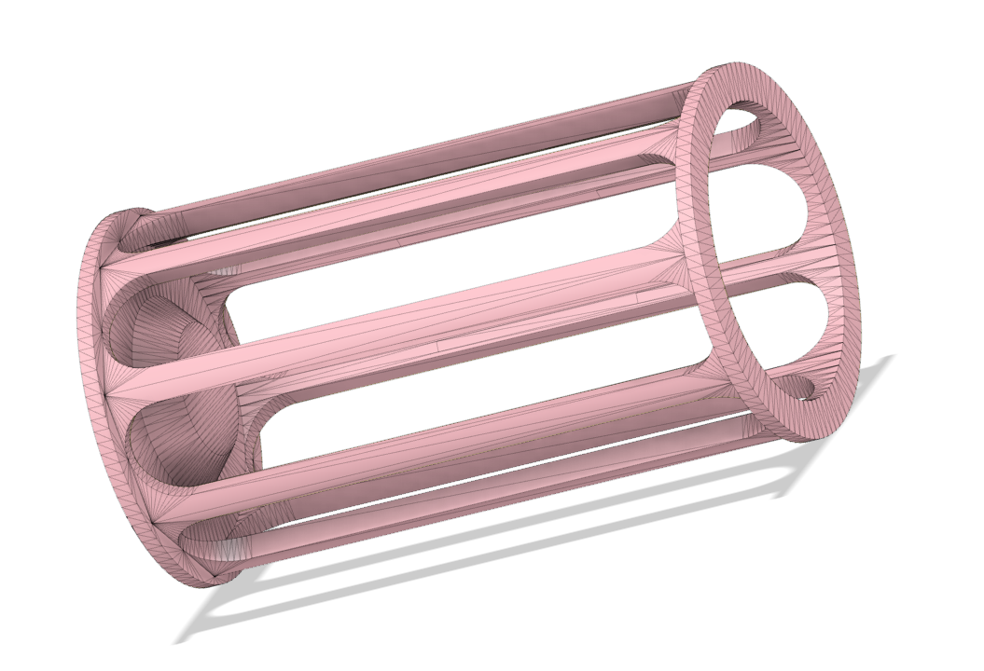

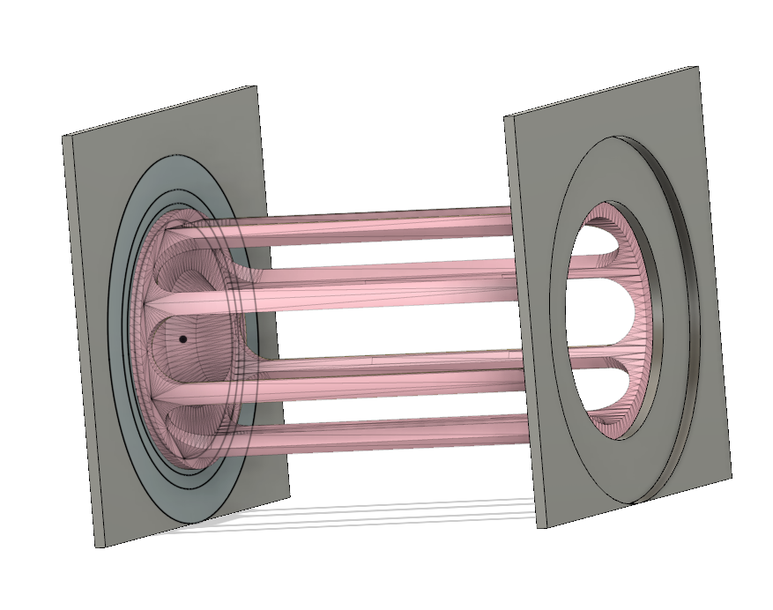

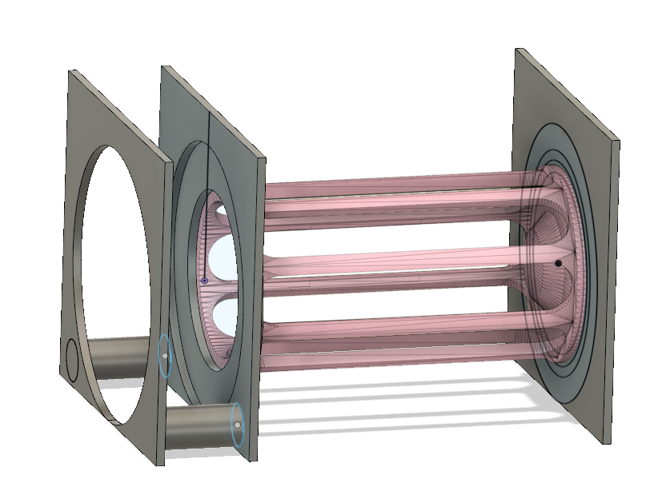

Rubbish conveyer place

